LAB 1

|  |
| --- |
| import java.util.Scanner; |
|  | class Main |
|  | { |
|  | public static void main(String[] args) |
|  | { |
|  | Scanner m = new Scanner(System.in); |
|  | System.out.print ( "Enter a,b,c of the equation:"); |
|  | double a=m.nextDouble(); |
|  | double b=m.nextDouble(); |
|  | double c=m.nextDouble(); |
|  | double d=((b*b)-(4*a*c)); |
|  | double root1 , root2 ; |
|  | if (d>=0) |
|  | { |
|  | root1= (-b - Math.sqrt(d))/(2*a); |
|  | root2= (-b + Math.sqrt(d))/(2*a); |
|  | System.out.println ("Two real roots are:"+root1+" "+root2); |
|  | } |
|  | else |
|  | { |
|  | System.out.println ("No real roots"); |
|  | } |
|  | } |
|  | } |

Output

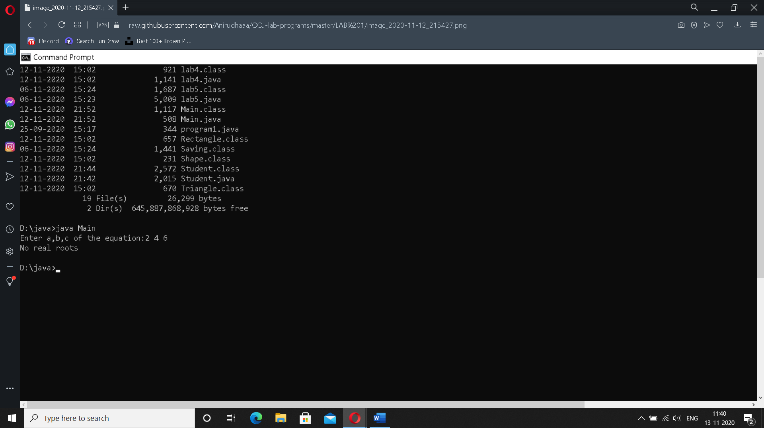

LAB 2

|  |
| --- |
| import java.util.Scanner; |
|  | class Student |
|  | { |
|  | String name; |
|  | String usn; |
|  | int marks[] = new int[5]; |
|  | int credits[] = new int[5]; |
|  | int i,n; |
|  | int grade=0; |
|  | double total=0; |
|  |  |
|  | void get_data() |
|  | { |
|  | Scanner in = new Scanner(System.in); |
|  | System.out.println("Enter Student Name:"); |
|  | name = in.next(); |
|  | System.out.println("Enter the USN:"); |
|  | usn = in.next(); |
|  | System.out.println("Enter the no. of subjects:"); |
|  | n=in.nextInt(); |
|  | System.out.println("Enter Subject credits and subject marks:"); |
|  | for(i=0;i<n;i++) |
|  | { |
|  | System.out.println("Credits for subject"+(i+1)+":"); |
|  | credits[i] = in.nextInt(); |
|  | System.out.println("Marks in subject"+(i+1)+":"); |
|  | marks[i] = in.nextInt(); |
|  | } |
|  | } |
|  |  |
|  | void calculate_sgpa() |
|  | { |
|  | for(i=0;i<n;i++) |
|  | { |
|  | if(marks[i]>=90 && marks[i]<=100) |
|  | grade=10; |
|  | else if(marks[i]>=80 && marks[i]<=90) |
|  | grade=9; |
|  | else if(marks[i]>=70 && marks[i]<=80) |
|  | grade=8; |
|  | else if(marks[i]>=60 && marks[i]<=70) |
|  | grade=7; |
|  | else if(marks[i]>=50 && marks[i]<=60) |
|  | grade=6; |
|  | else if(marks[i]>=40 && marks[i]<=50) |
|  | grade=5; |
|  | else if(marks[i]>=0 && marks[i]<=40) |
|  | grade=0; |
|  | else |
|  | System.out.println("Invalid marks entered"); |
|  | total=total+(grade*credits[i]); |
|  | } |
|  |  |
|  | total=total/20; |
|  | System.out.println("Sgpa="+total); |
|  | } |
|  |  |
|  | void stud_details() |
|  | { |
|  | System.out.println("Name:"+name); |
|  | System.out.println("USN:"+usn); |
|  | System.out.println("Marks & Credits of all subjects:"); |
|  | for(i=0;i<n;i++) |
|  | { |
|  | System.out.println("subject:"+(i+1)+":"); |
|  | System.out.println("Marks:"+marks[i]); |
|  | System.out.println("Credits:"+credits[i]); |
|  | } |
|  | calculate_sgpa(); |
|  | } |
|  |  |
|  | public static void main(String args[]) |
|  | { |
|  | Student s = new Student(); |
|  | s.get_data(); |
|  | s.calculate_sgpa(); |
|  | s.stud_details(); |
|  | } |
|  | } |

Output

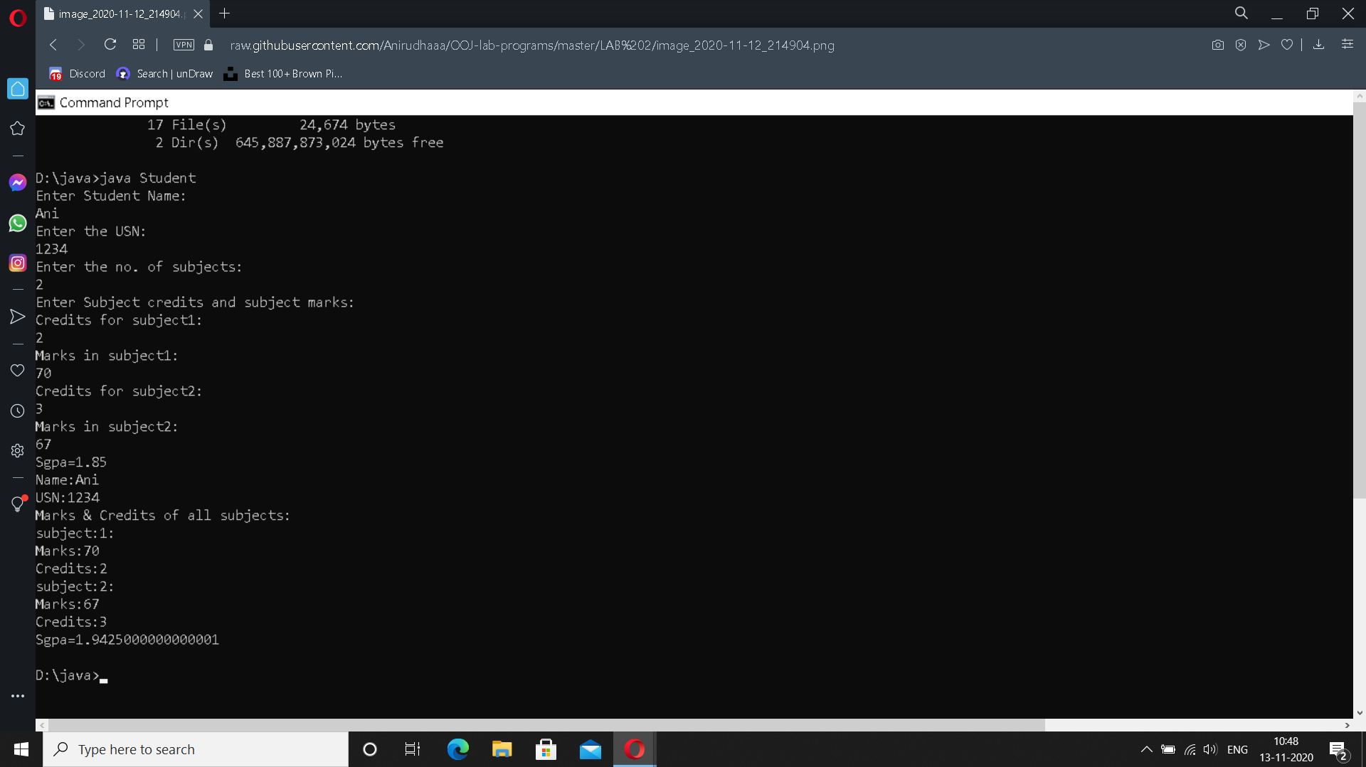

LAB 3

|  |
| --- |
| import java.util.Scanner; |
|  | class Book |
|  | { |
|  | private String name; |
|  | private String author; |
|  | private double price; |
|  | private int num_pages; |
|  |  |
|  | Book() |
|  | { |
|  | name="xyz"; |
|  | author="abc"; |
|  | price= 0.0; |
|  | num_pages=10; |
|  | } |
|  | void getdata() |
|  | { |
|  | Scanner sc= new Scanner(System.in); |
|  | System.out.println("enter name of book"); |
|  | name = sc.nextLine(); |
|  | System.out.println("enter name of author"); |
|  | author = sc.nextLine(); |
|  | System.out.println("enter price of book"); |
|  | price = sc.nextDouble(); |
|  | System.out.println("enter the number of pages"); |
|  | num_pages = sc.nextInt(); |
|  | } |
|  |  |
|  | public String toString() |
|  | { |
|  | return("Book: "+name+"\nAuthor: "+author+"\nPrice: Rs "+price+"\nNo.of pages: "+num_pages); |
|  | } |
|  | } |
|  | class lab3 |
|  | { |
|  | public static void main(String ss[]) |
|  | { |
|  | Scanner xx=new Scanner(System.in); |
|  | System.out.println("Enter the number of books:"); |
|  | int n=xx.nextInt(); |
|  | Book b[]=new Book[n]; |
|  | int i; |
|  | System.out.println("Enter the book details"); |
|  | for(i=0;i<n;i++) |
|  | { |
|  | System.out.println("Book "+(i+1)); |
|  | b[i]=new Book(); |
|  | b[i].getdata(); |
|  | } |
|  | System.out.println("Printing book details...."); |
|  | for(i=0;i<n;i++) |
|  | { |
|  | System.out.println("Book "+(i+1)); |
|  | System.out.println(b[i]); |
|  | System.out.println("-------------"); |
|  |  |
|  | } |
|  | } |
|  | } |

Output

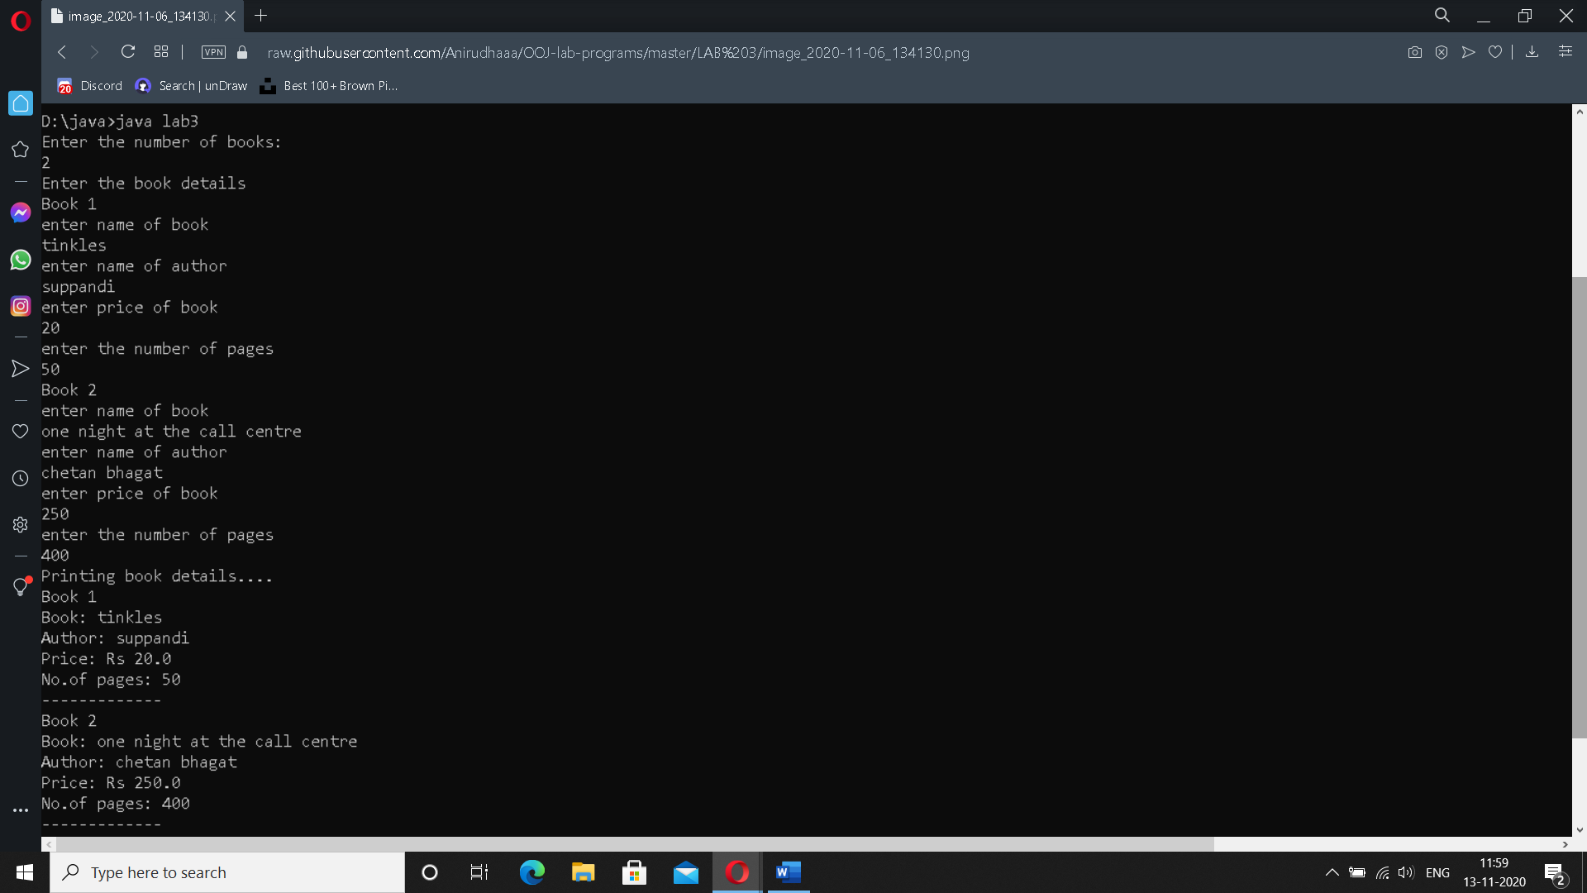

LAB 4

|  |
| --- |
| import java.util.Scanner; |
|  | abstract class Shape |
|  | { |
|  | int a; |
|  | int b; |
|  |  |
|  | abstract void printArea(); |
|  | } |
|  | class Rectangle extends Shape |
|  | { |
|  | Rectangle(int x, int y) |
|  | { |
|  | a=x; |
|  | b=y; |
|  | } |
|  |  |
|  | void printArea() |
|  | { |
|  | System.out.println("Area is "+(a*b)); |
|  | } |
|  | } |
|  |  |
|  | class Triangle extends Shape |
|  | { |
|  | Triangle(int x, int y) |
|  | { |
|  | a=x; |
|  | b=y; |
|  | } |
|  | void printArea() |
|  | { |
|  | System.out.println("Area is "+(a*b*0.5)); |
|  | } |
|  | } |
|  | class Circle extends Shape |
|  | { |
|  | Circle(int x) |
|  | { |
|  | a=x; |
|  | } |
|  | void printArea() |
|  | { |
|  | System.out.println("Area is "+(a*a*3.14)); |
|  | } |
|  | } |
|  |  |
|  | class lab4 |
|  | { |
|  | public static void main(String ss[]) |
|  | { |
|  | int l,b,ba,h,ra; |
|  | Scanner sc = new Scanner(System.in); |
|  |  |
|  | System.out.println("enter the length and breadth of rectangle"); |
|  | l= sc.nextInt(); |
|  | b= sc.nextInt(); |
|  | Rectangle r= new Rectangle(l,b); |
|  | r.printArea(); |
|  |  |
|  | System.out.println("enter the base and height of triangle"); |
|  | ba= sc.nextInt(); |
|  | h= sc.nextInt(); |
|  | Triangle t = new Triangle(ba,h); |
|  | t.printArea(); |
|  |  |
|  | System.out.println("enter the radius of circle"); |
|  | ra= sc.nextInt(); |
|  | Circle c = new Circle(ra); |
|  | c.printArea(); |
|  | } |
|  | } |

Output

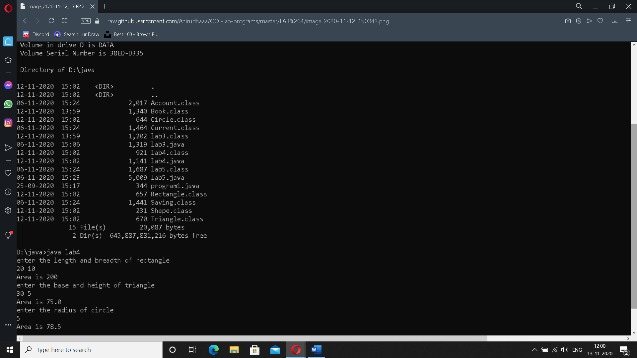

LAB 5

|  |
| --- |
| import java.util.Scanner; |
|  | import java.lang.Math; |
|  | class Account |
|  | { |
|  | String name; |
|  | int acctno; |
|  | char type; |
|  | double balance; |
|  | double dep; |
|  | boolean cheq; |
|  |  |
|  | void get(char c) |
|  | { |
|  | type = c; |
|  | if(c=='s' || c == 'S') |
|  | cheq=false; |
|  | else cheq=true; |
|  | Scanner sc = new Scanner(System.in); |
|  | System.out.println("Enter your name"); |
|  | name = sc.nextLine(); |
|  | System.out.println("Enter the account number"); |
|  | acctno = sc.nextInt(); |
|  | System.out.println("Enter the current available balance in your account"); |
|  | balance= sc.nextDouble(); |
|  | } |
|  |  |
|  | void putd() |
|  | { |
|  | System.out.println("Account details"); |
|  | System.out.println("Name: "+name); |
|  | System.out.println("Account number: "+acctno); |
|  | System.out.println("Account type :"+type); |
|  | System.out.println("balance: "+balance); |
|  | } |
|  | void dep() |
|  | { |
|  | Scanner ss = new Scanner(System.in); |
|  | System.out.println("Enter amount to be deposited"); |
|  | dep= ss.nextDouble(); |
|  | balance=balance +dep; |
|  | System.out.println("Amount is deposited and balance is updated"); |
|  | } |
|  | void display() |
|  | { |
|  |  |
|  | System.out.println("Balance amount is "+balance); |
|  | } |
|  |  |
|  | void check() |
|  | { |
|  | if(cheq==false) |
|  | System.out.println("Cheque book facility is not available"); |
|  | else |
|  | System.out.println("Cheque book facility is available"); |
|  |  |
|  | } |
|  |  |
|  |  |
|  | } |
|  |  |
|  | class Saving extends Account |
|  | { |
|  |  |
|  | double rate; |
|  |  |
|  | double s_with; |
|  | int n; |
|  |  |
|  | int ch; |
|  | double amt; |
|  | double term; |
|  | double pr; |
|  |  |
|  |  |
|  |  |
|  | void ci() |
|  | { |
|  | Scanner ss = new Scanner(System.in); |
|  | System.out.println("Enter the principal deposit amount"); |
|  | pr = ss.nextDouble(); |
|  | System.out.println("Enter rate of interest"); |
|  | rate = ss.nextDouble(); |
|  | System.out.println("Enter the term(years)"); |
|  | term = ss.nextDouble(); |
|  | System.out.println("Enter the number of times interest in compounded annually"); |
|  | n = ss.nextInt(); |
|  | amt = pr* Math.pow((1+(rate/100)),(n*term)); |
|  | balance+= amt; |
|  | System.out.println("Interest is compounded and deposited; balance is updated"); |
|  |  |
|  | } |
|  |  |
|  | void with_s() |
|  | { |
|  |  |
|  | Scanner ss = new Scanner(System.in); |
|  | System.out.println("Enter the amount of money to be withdrawn"); |
|  | s_with = ss.nextDouble(); |
|  | if(s_with>balance) |
|  | System.out.println("Insufficient balance"); |
|  | else |
|  | {balance= balance - s_with; |
|  | System.out.println("Money is withdrawn and balance is updated");} |
|  | } |
|  |  |
|  |  |
|  |  |
|  |  |
|  |  |
|  | } |
|  |  |
|  | class Current extends Account |
|  | { |
|  |  |
|  | double c_with; |
|  | double pen; |
|  | double min; |
|  | Current() |
|  | { |
|  | pen=100; |
|  | min=500; |
|  | } |
|  |  |
|  | void with_c() |
|  | { |
|  | Scanner xx = new Scanner(System.in); |
|  | System.out.println("Enter the amount to be withdrawn"); |
|  | c_with= xx.nextDouble(); |
|  | if(c_with>balance) |
|  | {System.out.println("Insufficient funds!"); |
|  | return;} |
|  | else |
|  | {balance= balance- c_with; |
|  | System.out.println("Amount is withdrawn and balance is updated");} |
|  | if(balance<min) |
|  | { |
|  | System.out.println("Balance is below the minimum threshold. Service penalty charge = 100/- ."); |
|  | if(balance<pen) |
|  | System.out.println("Due to insufficient funds, penalty charge will be deducted from account after replenishing. Current balance is "+balance); |
|  | else |
|  | { |
|  | balance= balance-pen; |
|  | System.out.println("Penalty charge has been deducted from account balance. Current balance is "+balance); |
|  | } |
|  | } |
|  | } |
|  |  |
|  |  |
|  | } |
|  |  |
|  | class lab5 |
|  | { |
|  | public static void main(String sss[]) |
|  | { |
|  | int cch, chh; |
|  | Scanner sx = new Scanner(System.in); |
|  | System.out.println("Welcome"); |
|  | System.out.println("Savings account or current account? 1- Savings; 2- Current"); |
|  | int ch= sx.nextInt(); |
|  | if(ch==1) |
|  | { |
|  | Saving s = new Saving(); |
|  | s.get('S'); |
|  | do{ |
|  | System.out.println("1. Deposit money\n2. Calculate compound interest\n3. Withdraw money\n4. Display balance\n5. Cheque book facility\n6. Exit"); |
|  | System.out.println("Enter your choice"); |
|  | chh= sx.nextInt(); |
|  | switch(chh) |
|  | { |
|  | case 1: |
|  | s.dep(); |
|  | break; |
|  |  |
|  | case 2: |
|  | s.ci(); |
|  | break; |
|  |  |
|  | case 3: |
|  | s.with_s(); |
|  | break; |
|  |  |
|  | case 4: |
|  | s.display(); |
|  | break; |
|  |  |
|  | case 5: |
|  | s.check(); |
|  | break; |
|  |  |
|  | case 6: |
|  | break; |
|  |  |
|  | default: |
|  | System.out.println("Wrong option."); |
|  | break; |
|  | } |
|  | }while(chh!=6); |
|  |  |
|  | } |
|  | else if(ch==2) |
|  | { |
|  | Current cr = new Current(); |
|  | cr.get('C'); |
|  | do{ |
|  | System.out.println("1. Deposit money\n2. Chequebook facility\n3. Withdraw money\n4. Display balance\n5. Exit"); |
|  | cch= sx.nextInt(); |
|  | switch(cch) |
|  | { |
|  | case 1: |
|  | cr.dep(); |
|  | break; |
|  |  |
|  | case 2: |
|  | cr.check(); |
|  | break; |
|  |  |
|  | case 3: |
|  | cr.with_c(); |
|  | break; |
|  |  |
|  | case 4: |
|  | cr.display(); |
|  | break; |
|  |  |
|  | case 5: |
|  | break; |
|  |  |
|  | default: |
|  | System.out.println("Wrong option."); |
|  | break; |
|  | } |
|  | }while(cch!=5); |
|  |  |
|  |  |
|  |  |
|  | } |
|  | else System.out.println("Wrong!"); |
|  | } |
|  | } |

Output

